ASES and 21st CCLC Program Site Coordinator Community of Practice Pilot
Information for Program Directors and Supervisors

Background
In January 2014 the California Department of Education After School Division (CDE-ASD) Released A Vision for Expanded Learning in California – Strategic Plan: 2014-2016. The vision was developed by the California Department of Education in collaboration with K-12 educators, program practitioners, and support providers. A core component of this vision was the creation of Quality Standards. The Quality Standards for Expanded Learning in California were created and informed by a variety of field stakeholders over a two-year process facilitated by the California AfterSchool Network Quality Committee.
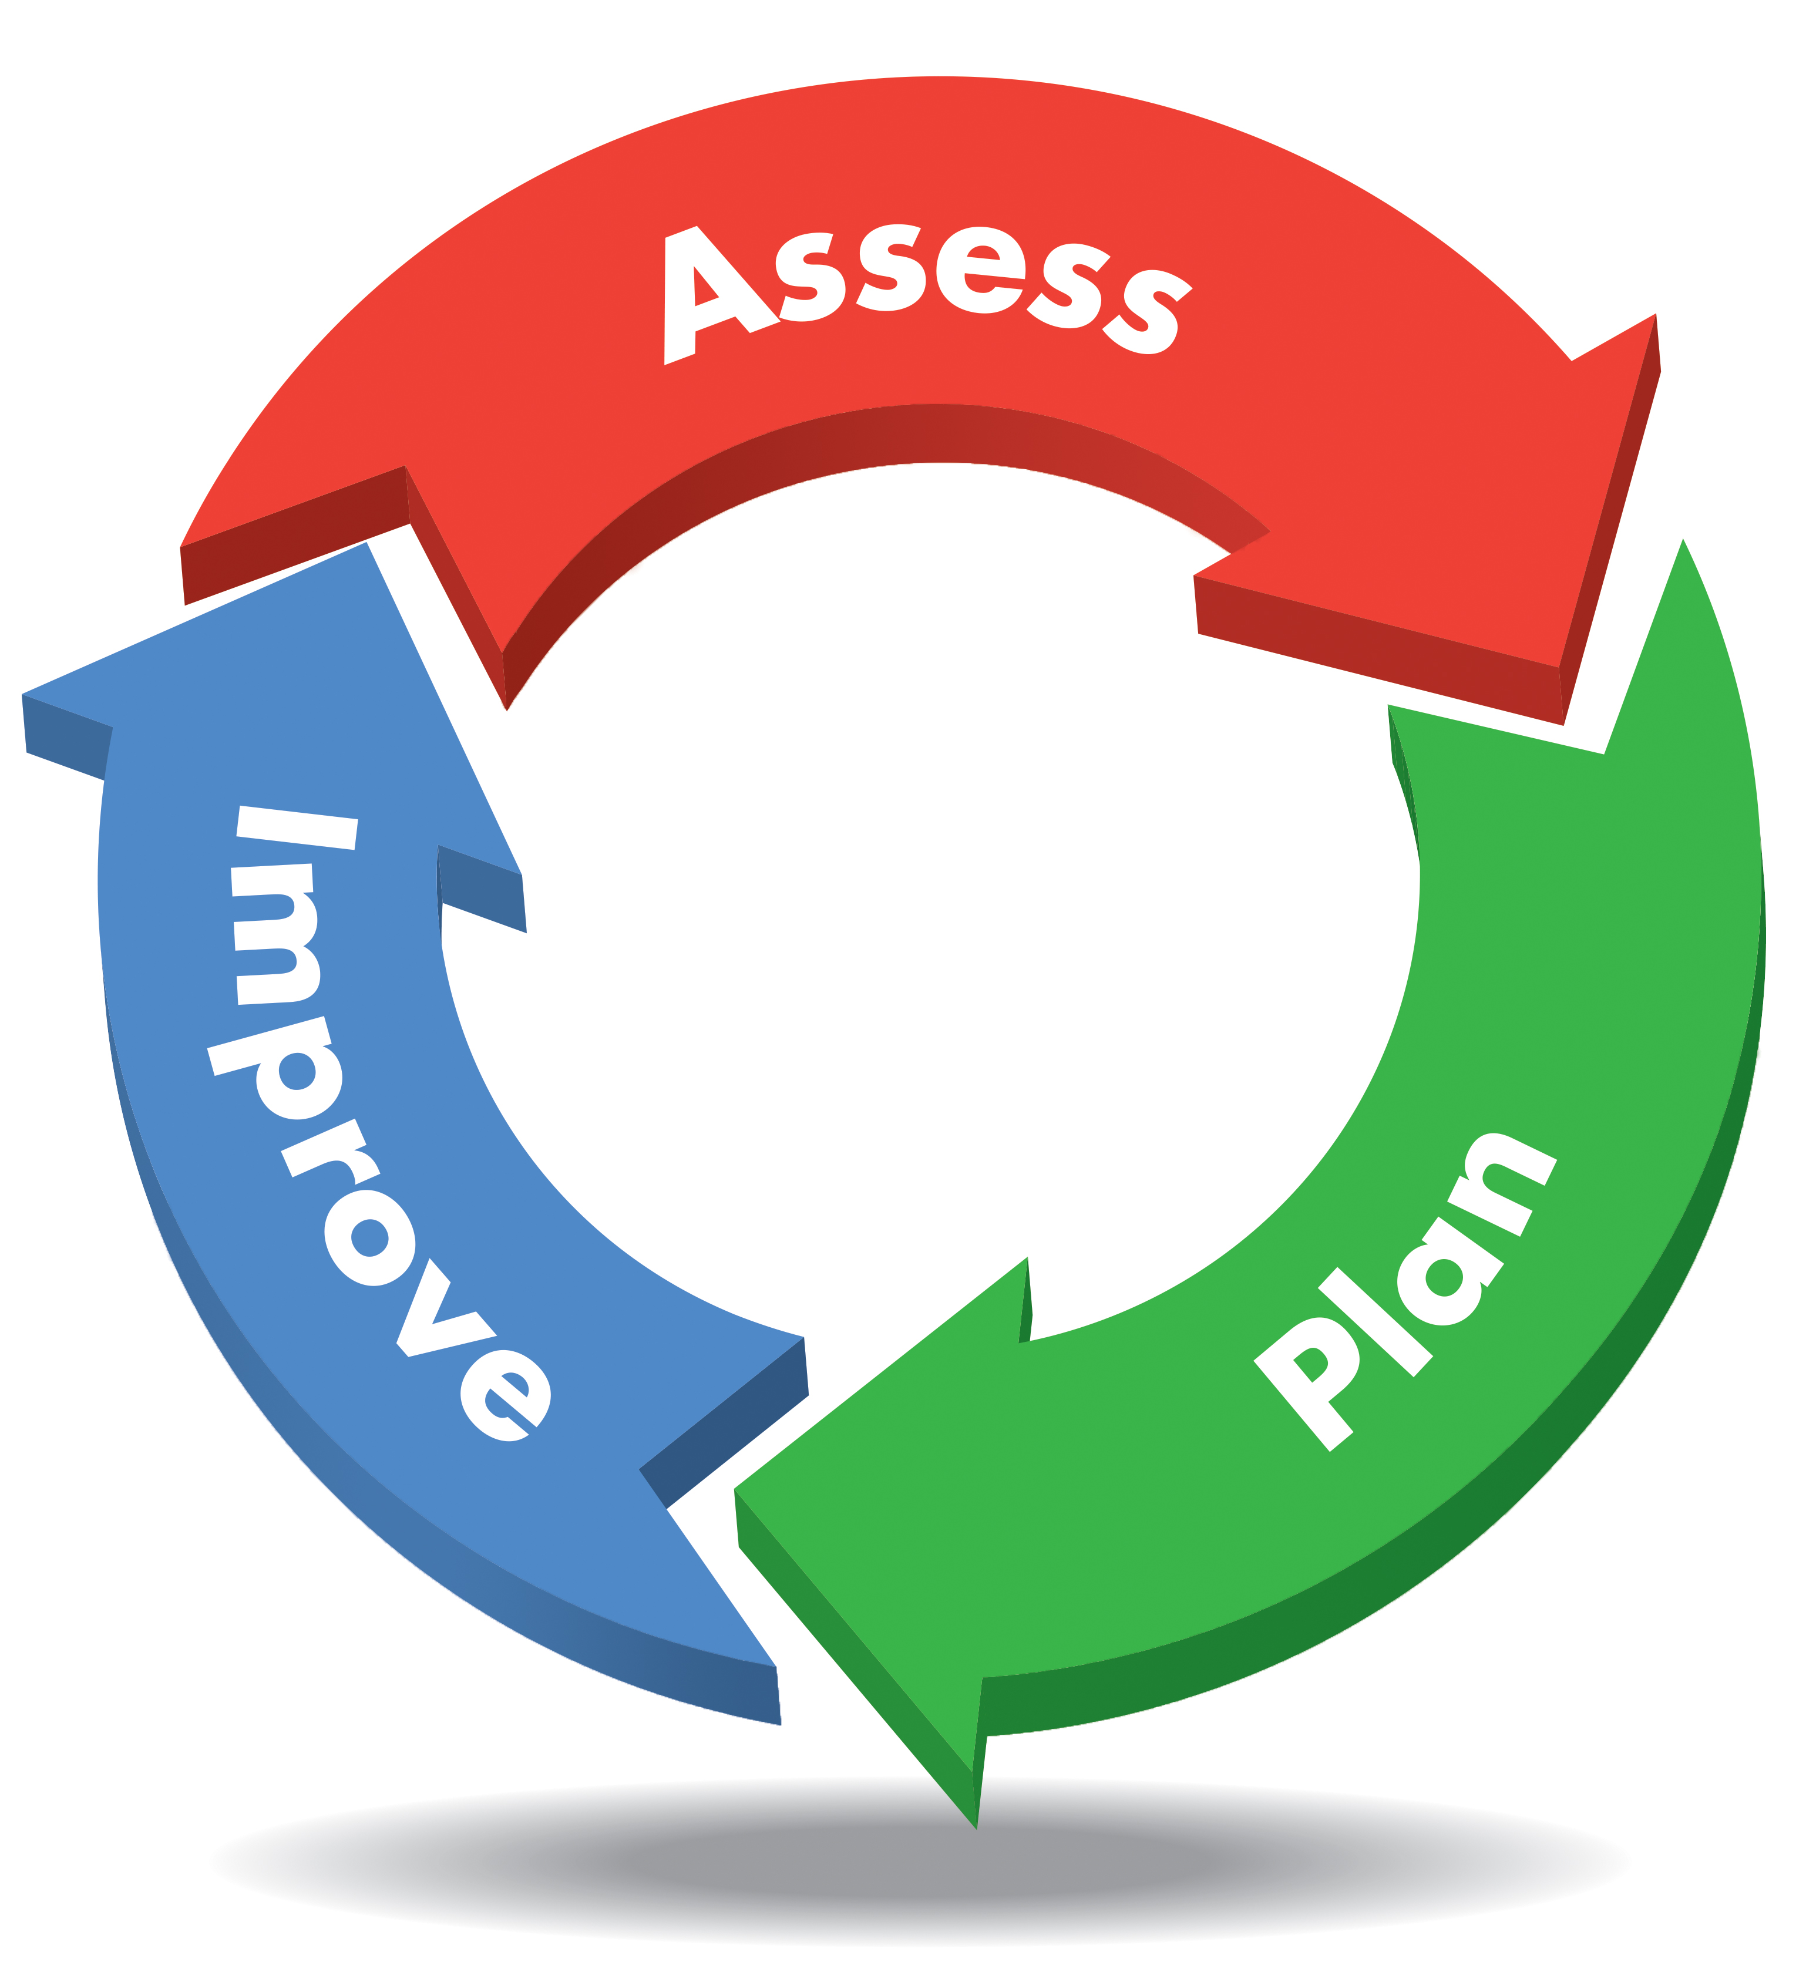
The Quality Standards were approved and released by the California Department of Education in September 2014, and in that same month Governor Jerry Brown approved SB 1221. The passage of SB 1221 and the release of Quality Standards for Expanded Learning in California created an instant shift in the nations largest expanded learning infrastructure. The law created a new requirement for expanded learning programs to, “provide evidence of a data-driven program quality improvement process that is based on department’s guidance on program quality standards.” One year after the passage of SB 1221, now codified in Education Code as EC 8484 (a)(2), expanded learning programs in California submitted Commitments to Engage in a Program Quality Improvement (CQI) Process. The next step to engage in a CQI process is to create site level Program Quality Improvement Plans.

What is a Community of Practice?
Have you ever attended workshop or conference and, even though the training was valuable, the biggest takeaway came from a quick hallway conversation where a colleague shared a resource or innovation with you? This is the essence of a Community of Practice. Communities of Practice combine the best of both worlds. Participants will receive professional development, but they won’t have to rush or duck out of the room to have those invaluable hallway conversations. Learning from others, and sharing knowledge and innovative ideas is an essential part of the experience!

The term, “Communities of Practice” was first used in 1991 by theorists Jean Lave and Etienne Wenger, they are defined as, “a process of social learning that occurs when people who have a common interest in a subject or area collaborate over an extended period of time, sharing ideas strategies, determine solutions, and build innovations.” A more simplified definition is, “A group of people who share a concern or passion for what they do and learn how to do it better as they interact regularly.” Learn more about communities of practice by visiting this site, and this site.

Why should Site Coordinators participate?

Participants will:
- Build their knowledge and capacity regarding Quality Standards for Expanded Learning in California and the Continuous Quality Improvement (CQI) process, as well as available technical assistance and resources.
- Learn and share innovative and promising practices related to Quality Standards.
- Surface successes, challenges, and needs of Site Coordinators to effectively implement site-level CQI processes to inform how the larger statewide system of support can better support Site Coordinators!

Who is eligible to participate?
The Site Coordinator Community of Practice Pilot aims to recruit After School Education and Safety (ASES) or 21st Century Community Learning Centers (21st CCLC) Site Coordinators that:
- Have approximately two years experience in the expanded learning field.
- Perceive they will be in the field next year.
- Are personally motivated to apply.
- Are willing and enthusiastic to fulfill all program commitments. Program commitments include active, engaged participation in three, ½ day meetings (with no more than 2 hours of additional effort between meetings).
- Have the support of their supervisor to participate, and provide contact information for their supervisor as part of their application.
- Have the ability to travel to local Community of Practice meetings.

What is expected of Site Coordinator participants?
A Community of Practice is all about learning with a group of individuals over a period of time. . Therefore, participants in the Site Coordinator Community of Practice Pilot must commit to attending all three meetings. Participating site coordinators will commit to participating in three (4.5 hour) meetings (including lunch) in March, April, and early May 2016. There may be additional work between meetings not to exceed two hours between each meeting.

Meeting one: (March 2016)
- Teambuilding and creating a cohort
- Overview: Expanded Learning in CA, Quality Standards, and CQI
- Focused discussion: Promising practices related to Quality Standards

Meeting two: (April 2016)
- Focused discussion: Strategies and challenges in the implementation of a CQI process.
- Overview: Resources and Technical Assistance available to support a CQI process.

Meeting three: (May 2016)
- Overview: The future of CQI
- Focused discussion: Successes, challenges, and future needs of site coordinators to implement a site-level CQI process.

Where will meetings take place?
Information to be included specific to region.

What is Expected of Program Directors or Supervisors of Site Coordinators?
Successful participation in a Site Coordinator Community of Practice Pilot can only be accomplished with quality support from Program Directors and/or supervisors. Additionally, effective implementation of the CQI process on sites can only be accomplished with Program Director support for CQI implementation on site. In order to facilitate success of the project it is essential that Program Directors:
- Participate in a 60-minute (virtual) Site Coordinator Community of Practice information and orientation session.
- Participate in three 60-minute (virtual) Site Coordinator Community of Practice review sessions to inform supervisors regarding what was covered.
- Support their Site Coordinators to attend (e.g., compensate staff for participation, and work with site coordinators to address any barriers to participation, hold staff accountable for attending all three meetings).

How can I encourage my eligible site coordinators to apply?
- Access the application (final page of this document)
- Access the Site Coordinator information sheet and application at this website
- Encourage them to submit their application (including assurance of supervisor support for participation) to (INSERT REGIONAL LEAD APPROPRIATE CONTACT INFORMATION) by March 4, 2015.
- Applicants will be notified of their participation on March 11, 2015.
- Be sure to save the date for the first meeting which will take place (ESTABLISHED MARCH DATE FOR THE MEETING)

Where can I find more information?
REGIONAL CONTACT INFORAMTION HERE
WEB PAGE HERE

