**2 North Hollywood High teams compete for national cyber security title**

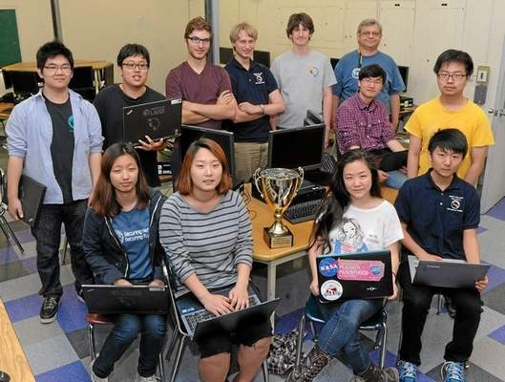Front row, from left, Woo jin Cheon, Annie Shim, Jamie Chang, Isaac Kim; Back row: John Yoon, Issac Kim, Camden Bickel, Henry Birge-Lee, Travis Raser, Advisor Jay Gehringer, Richard Wang and Jaeyeong Hwang. This group of students from North Hollywood High School will travel to Washington D.C. next month to compete against 2,100 teams from the U.S. and Canada in cyber security. John McCoy — Staff photographer

By [Thomas Himes](http://www.dailynews.com/social-affairs/20150215/2-north-hollywood-high-teams-compete-for-national-cyber-security-title#author1), Los Angeles Daily News

Posted: 02/15/15, 3:47 PM PST | Updated: 40 secs ago

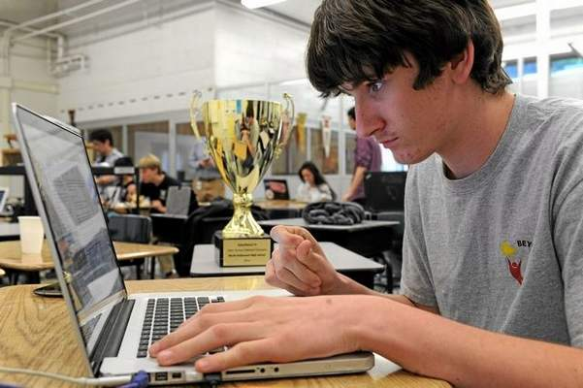Travis Raser sits next to last years trophy while working on a problem. John McCoy — Staff photographer

Defense will be the game next month when two teams from North Hollywood High School travel to Washington, D.C., to compete in a prestigious national championship.

But the North Hollywood High competitors that bested 2,100 teams from every state and Canada through the first four rounds of this year’s competition to make it to the final 12 teams won’t be wearing protective pads or taking a field at the March 11 competition.

Instead, the 10 students will spend several hours hunting simulated hackers, ousting computer viruses and securing networks in the National Student Cyber Defense Championship.

“It’s six hours straight, and it’s time pressure too; we almost always come down to the wire,” senior Henry Bridge-Lee said of the first four rounds of competition this year. “We’re working the entire time, we eat in front of our computers.”

Bridge-Lee and his four teammates on team Azure have spent the school year training three evenings a week and Saturdays as part of Los Angeles Unified’s after-school program CyberPatriot.

The program and competition were created by the Air Force Association, a booster club of sorts for the U.S. Air Force, to promote science, technology, engineering and math (STEM) in schools.

LAUSD’s after-school arm, Beyond the Bell, began participating in the program five years ago, and North Hollywood launched its program — 15 teams of five students each — four years ago. After performing well during the first few years of competitions, team Azure won last year’s championship in the nation’s capital.

This year, all three California teams to make it to Washington, D.C., are from LAUSD. In addition to North Hollywood High’s Azure and Silver teams, Benjamin Franklin High School in Highland Park will send a team.

North Hollywood High teacher Jay Gehringer said he launched the campus’s program because it seemed “fun.” But it’s not his first success leading LAUSD students in competition. During his previous work coaching band for 27 years, Gehringer’s pupils won the Los Angeles Band and Drill Team Championship 10 times. But after teaching his first computer class nearly three decades ago using Apple 2C’s, which resembled typewriters with black and white televisions mounted on top, the past four years have been his first foray into competition with computers.

“They tell me I’m just a competitor and can build teams,” Gehringer said.

He said their top competitor, a Virginia school, trains during school hours because cybersecurity is offered as a course of study.

Aside from his competitive nature, Gehringer’s success at persuading cybersecurity experts from Cisco and Microsoft to volunteer their time instructing his students has also helped. On Friday, a collegiate competitor from Cal Poly Pomona was volunteering his afternoon to help Gehringer’s students train.

Like any group of elite competitors, the North Hollywood High techies are hoping their performance will impress recruiters.

Senior Issac Kim said his efforts in the national championship last year landed him and one of his teammates paid internships at a national defense contractor, which, he said, can’t be identified for security reasons.

“They were impressed with what we did,” said Kim, who has been working for the company since last summer.

But as the all-male team Azure looks to become a dynasty in the sport of cyberdefense, members of North Hollywood’s other qualifying team are hoping to pull off an upset.

Jamie Chang, one of three girls on team Silver, said she’ll also be looking to prove women are no different from men when it comes to science and engineering.

Chang, who will be attending Massachusetts Institute of Technology in the fall, said she’s faced sexism in the field, as men have told her she was only accepted to the prestigious university to fill a quota and implied that females are inferior.

“I remember last year, we were learning to do (computer) hardware, and the males were having a harder time than us,” Chang said. “The instructor said, ‘Are you going to let a girl beat you?’ ”

“I thought, ‘Why does that have to be a thing?’ ”

Chang said she wants the win for women everywhere.

“It would mean a lot to me, because it shows females can do a lot too,” she said